Bash Script Test

- Create one Bash script to check if a directory is available or not.
Steps: Creating the file
Check_directory.sh
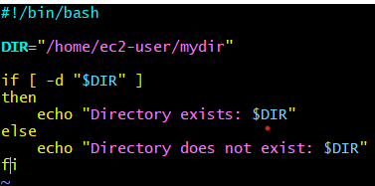
chmod +x check_directory.sh
./check_directory.sh
Output:
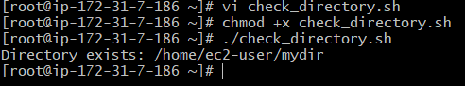
- Create a Bash script which will create multiple files.
Create file: create_files.sh

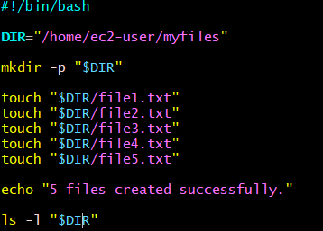
chmod +x create_files.sh
./create_files.sh

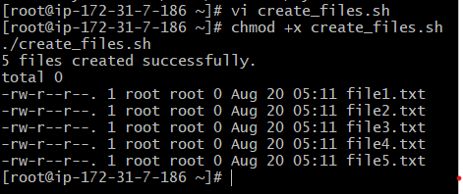

- Create a Bash script to take backup of a directory.
Create file: vi backup_directory.sh
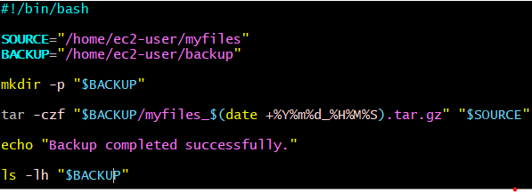
Giving the permissions chmod+x backup_directory.sh
To get output: ./backup_directory.sh
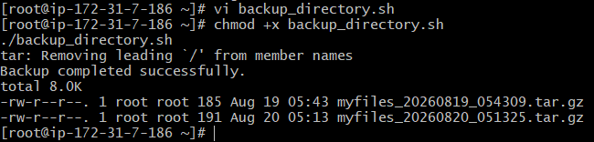
To check the backup:
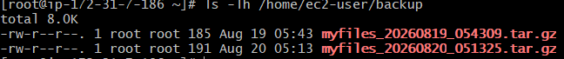
- Create a Bash script to install nginx in an EC2 server.
creating the file: install_nginx.sh
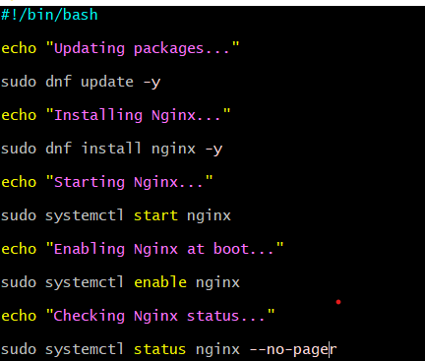
chmod +x install_nginx.sh
./install_nginx.sh

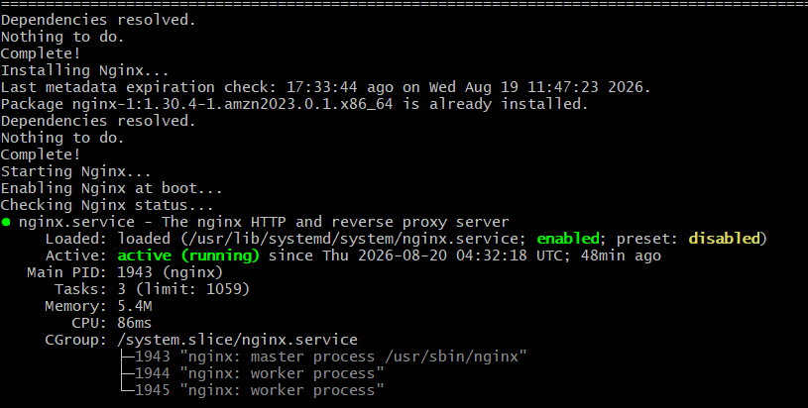
Run: systemctl status nginx
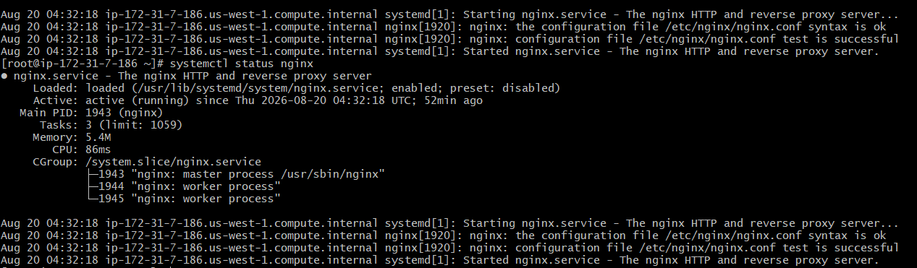
- Create a Bash script to install Apache Tomcat in an EC2 server.
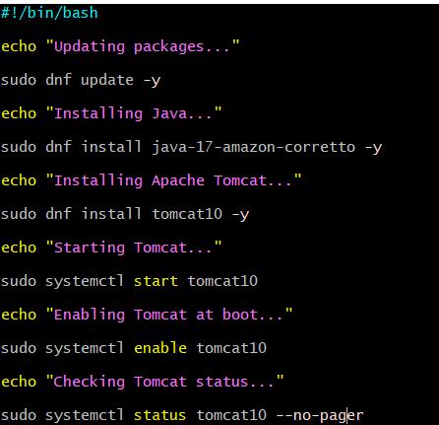

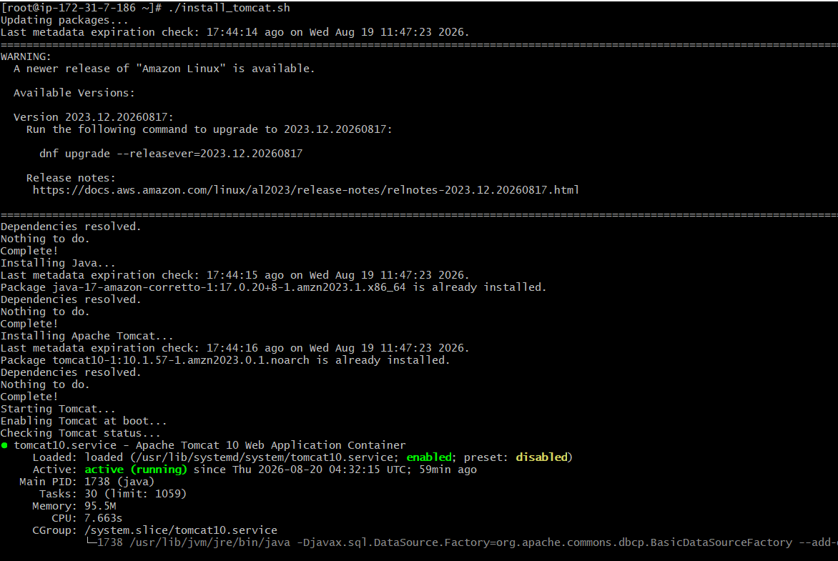
Check: ps -ef | grep tomcat

- Create a Bash script to check if nginx service is running or not.
  - If not running, the script should start the service.
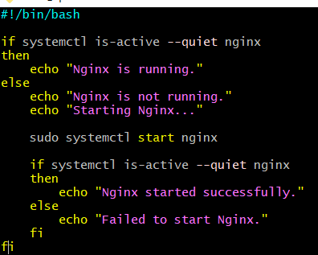
chmod +x check_nginx.sh
./check_nginx.sh

- Create a Bash script to check if a directory is available or not.
  - If not, then create the directory.
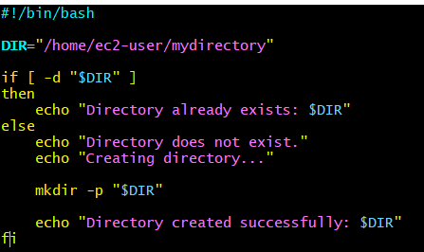
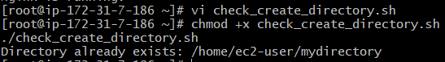
- Create a Bash script to delete the last 3 lines from a file.
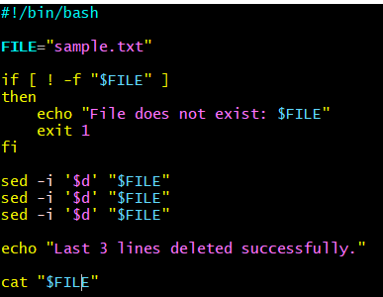
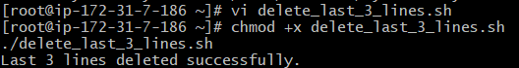

- Create a Bash script to monitor CPU usage.
  - If CPU > 80%, then send an email notification.
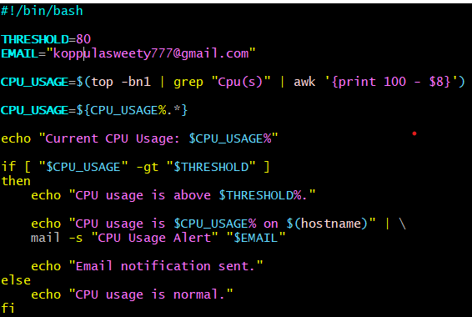
chmod +x cpu_monitor.sh
./cpu_monitor.sh
Output:
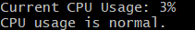

- Create a Bash script to monitor Disk Space.
  - If usage > 80%, then send an email notification.
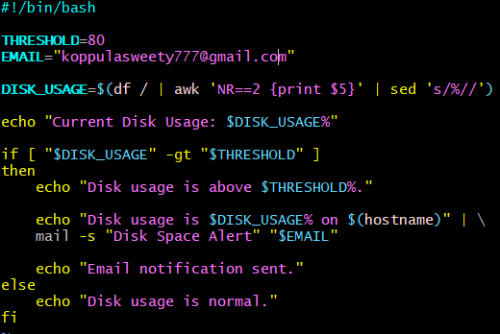
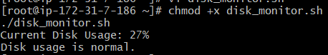

- Create a Bash script to monitor Memory Usage.
  - If usage > 80%, then send an email notification.
